CEG3156 | Spring 2024



GROUP 10

Laboratory #2: Single Cycle Processor

Course Professor: Dr. Rami Abielmona

Name | Student ID
Josue Dazogbo | 300258449
Christopher King | 300226522
Table of Contents
Introduction 3
Objectives 3
Main Objective 3
Learned Objectives 3
Prelab 4
Branch Not Equal To 4
Clock Period Calculation 5
Problem and Solution Discussion 6
Instruction Memory 7
Program Counter Logic 7
Register File 8
ALU 8
Datapath 8
Control Path 9
Data Memory 10
Control Logic 10
Verification 11
RAM 11
ROM 12
ALU 12
Control Path 13
Sign Extension 13
Demo 13
Top Level Entity 13
Pin Assignments 14
Bonus 14
32 Bit Design 14
Multi-cycle Design 15
Comparison With Single Cycle 16
Appendix 17
Hand calculations 17
Test program in binary 19
VHDL Components 21
Processor.vhd 21
ALU.vhd 23
All code: 24

Introduction
The purpose of this lab is to design, implement, and test a single cycle RISC style processor using the MIPS instruction set. This processor has been designed using the data paths and control logic provided in the lab manual and throughout the class. The processor will be tested using an example program seen in the appendix. This lab will strengthen and solidify understanding of single cycle processors and the MIPS architecture.

Objectives

Main Objective
The primary objective of this laboratory is to design and build a single-cycle RISC-type processor in VHDL. This involves understanding the architecture and functionality of a RISC processor, implementing the necessary hardware components, and verifying their functionality through simulation and physical implementation on an FPGA board.

Learned Objectives
Throughout the course of this lab, the following objectives were achieved:
- Design and Implementation of a Single-Cycle RISC Processor: Designed, realized, and tested a single-cycle RISC processor, gaining hands-on experience with RISC architecture and instruction set architectures.
- Addition of New Instruction (bne): Modified the datapath and control signals to support the 'branch if not equal' (bne) instruction, demonstrating an understanding of control flow instructions in a RISC processor.
- Understanding of MIPS Instruction Formats: Developed a comprehensive understanding of MIPS instruction formats, including R-type, I-type, and J-type instructions, and their roles in processor operations.
- VHDL Coding and Simulation: Practiced writing VHDL code at the structural level, ensuring a deeper understanding of Register Transfer Logic (RTL) design. Simulated designs to verify correctness against theoretical expectations.
- FPGA Implementation and Testing: Implemented the processor design on a Cyclone FPGA board, using DIP switches to input values and LEDs to display the output. This provided practical experience with hardware design and debugging.
- Problem-Solving and Troubleshooting: Enhanced problem-solving and troubleshooting skills through the process of design, simulation, and physical testing, learning how to overcome various design obstacles.
- Efficiency Calculation: Calculated the CPU execution time and maximum clock frequency of the processor, providing an understanding of performance metrics for single-cycle processors.
By completing these tasks, we not only met the main objective of the lab but also gained valuable skills and knowledge that will be applicable in future digital logic and computer systems design projects.

Prelab

Branch Not Equal To
Creating a branch if not equal instruction (BNE) can be completed using similar logic to the branch equal to (BEQ) instruction. The loading of the program counter is controlled by multiplexers called branch and jump. The multiplexer control can be modified to select the branch target address (BTA) when the zero flag is 0 and the BNE control signal is active OR when the zero flag is 1 and the BEQ control signal is active.
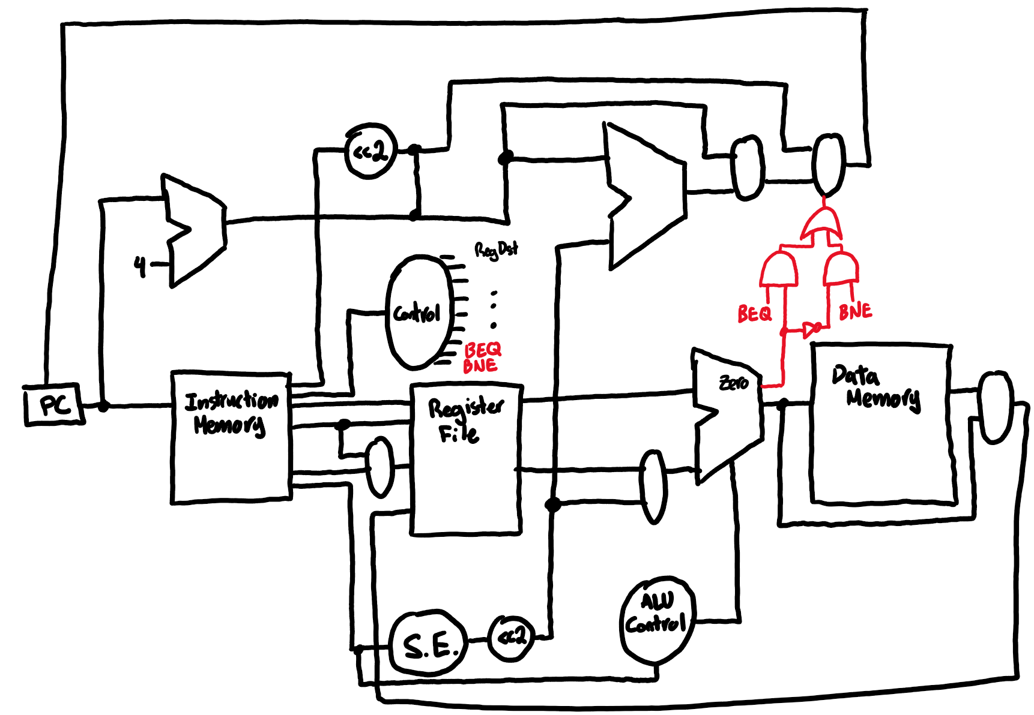
Figure 1. Datapath with BNE instruction

Clock Period Calculation
Calculating the clock period for a digital system, such as a processor, involves determining the maximum time required for the longest path (also known as the critical path) between two sequential elements in the circuit. This critical path includes the propagation delays through logic gates and interconnects, as well as setup and hold times for registers. The clock period must be greater than or equal to the sum of these delays to ensure correct timing and data integrity. Our ALU design is predicted to have 53 separate gates in the critical path length mostly because of our 32 bit ripple carry adder circuit. We ignore the very short delay introduced by multiplexers since they only contain 2-3 gates in their critical path length. Adding up all the times from the lab manual, we can generate this table for each instruction.
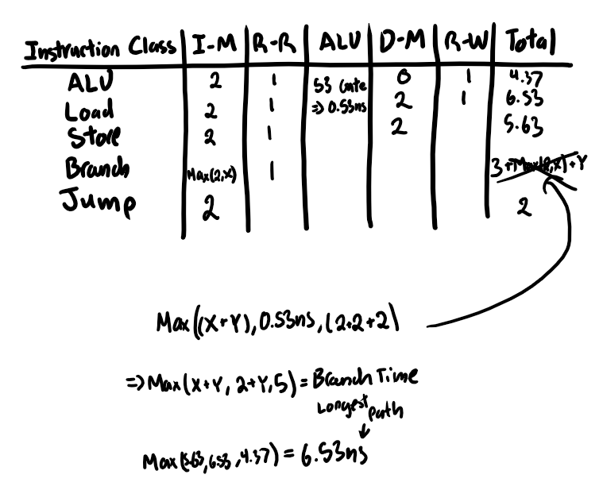
Figure 2. Timing Diagram for Various Instructions

Problem and Solution Discussion
In this laboratory, the task is to design and implement a single cycle MIPS processor using VHDL. This requires the design of the data path and control path separately. The data path was designed using existing diagrams of the MIPS processor provided in the lab manual with modified bus widths. The word size of this processor is 8 bits while supporting a 32-bit instruction. This requires the registers, ALU, and data memory to be adjusted to support the 8-bit word.

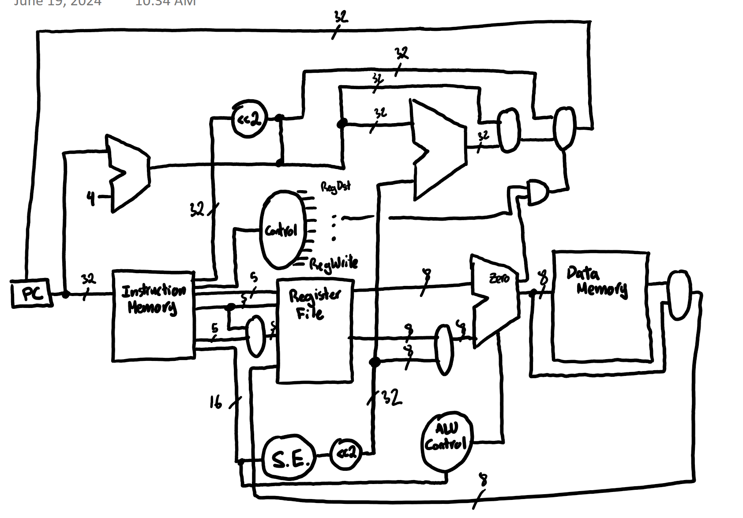
Figure 3. Top level data path

Instruction Memory
The processors instruction memory is a 32-bit word with 8 address lines. This allows the processor to address 256 unique instructions. This was implemented using a pre-build Altera LPM component LPM_ROM. This component allows data to be programmed in Quartus using an MIF file and to be read in simulations and using the FPGA. This component was then used in a VHDL wrapper to simulate the ROM and verify functionality.

Program Counter Logic
As specified in the lab manual, the processor has access to 256x32 of instruction memory. This means the instruction memory has 8 address bits and therefore the program counter has 8 bits. The program counter has 3 possible loads. Under normal operation (no branch or jump) the PC is simply incremented.
When executing a branch instruction, the branch target address is calculated by a separate ALU that adds current program counter with the offset. The main ALU then compares the value of the 2 registers and controls the mux to either load the BTA or the incremented PC (if the branch is not taken).
When executing a jump instruction, the address is loaded into the jump mux and the control unit asserts the jump signal to select the jump address instead of the regular incremented PC.

Register File
The register file (RF) consists of 8 registers of 8 bits each. The RF has 2 read ports and 1 write port that can all be accessed within a single cycle. Each port has a 3-bit register select input. These 3 bits control an output multiplexer for the read ports and are used to assert a write signal to a register for the write ports using a decoder.

ALU

Datapath
The ALU consists of the ALU data path and the ALU control unit. The ALU data path consists of an 8-bit adder for addition and subtraction operations as well as logic gates for OR and AND. The ALU output is controlled by an 8-bit multiplexer to select between the different operations.
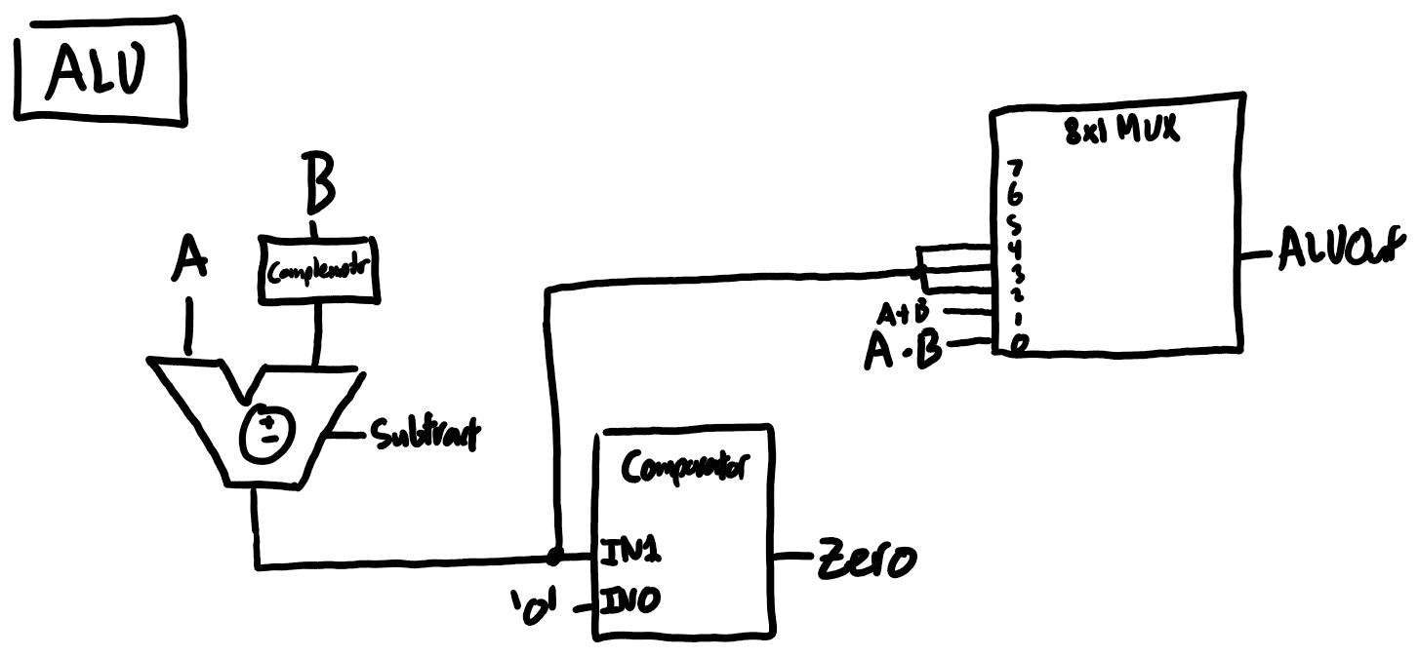
Figure 4. High level ALU data path

Control Path
The ALU operation is controlled by both the op code of the executing instruction and a function code. R-type instructions specify ALU operation with a function code while other instructions may need to use the ALU for other purposes (such as calculating an effective address). The control logic was designed using the following truth table.
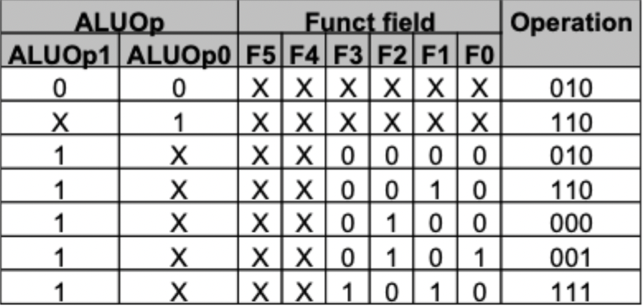
Figure 5. ALU Control Operations
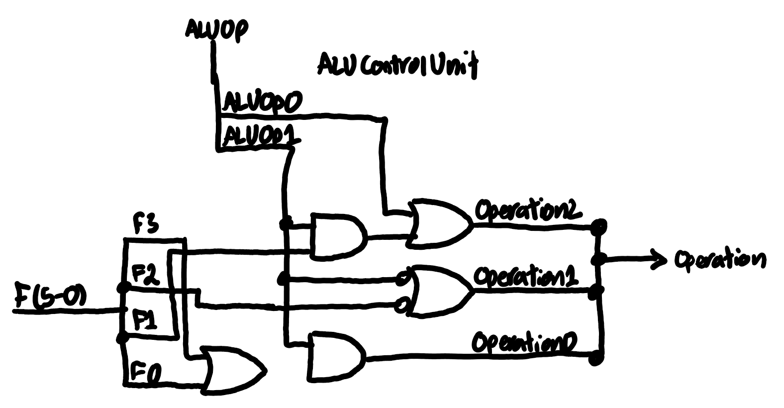
Figure 6. ALU Control Unit

Data Memory
The processors data memory is an 8-bit word with 8 address lines. This allows the processor to address 256 unique words in ram. This was implemented using a pre-build Altera LPM component LPM_RAM_DQ. This component allows data to be programmed in Quartus using an MIF file and to be read and written in simulations and using the FPGA. This component was then used in a VHDL wrapper to simulate the RAM and verify functionality.

Control Logic
The control path was designed according to the following table and flow chart shown in figure 4. These diagrams were then used to create a gate level implementation shown in figure 5.
Instruction | RegDst | ALUSrc | Mem-to-Reg | Reg Write | Mem Read | Mem Write | Branch | ALUOp1 | ALUOp0
R-format | 1 | 0 | 0 | 1 | 0 | 0 | 0 | 1 | 0
lw | 0 | 1 | 1 | 1 | 1 | 0 | 0 | 0 | 0
sw | X | 1 | X | 0 | 0 | 1 | 0 | 0 | 0
beq | X | 0 | X | 0 | 0 | 0 | 1 | 0 | 1
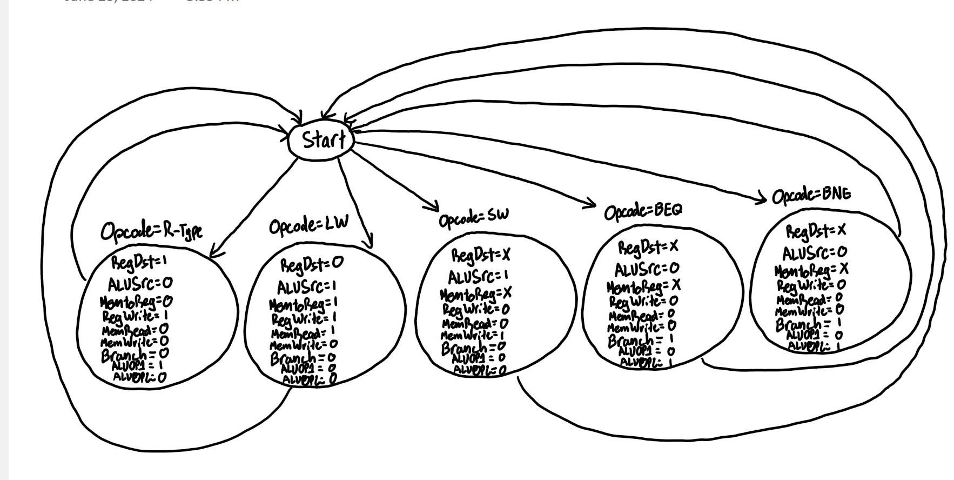
Figure 7. Control logic flow chart
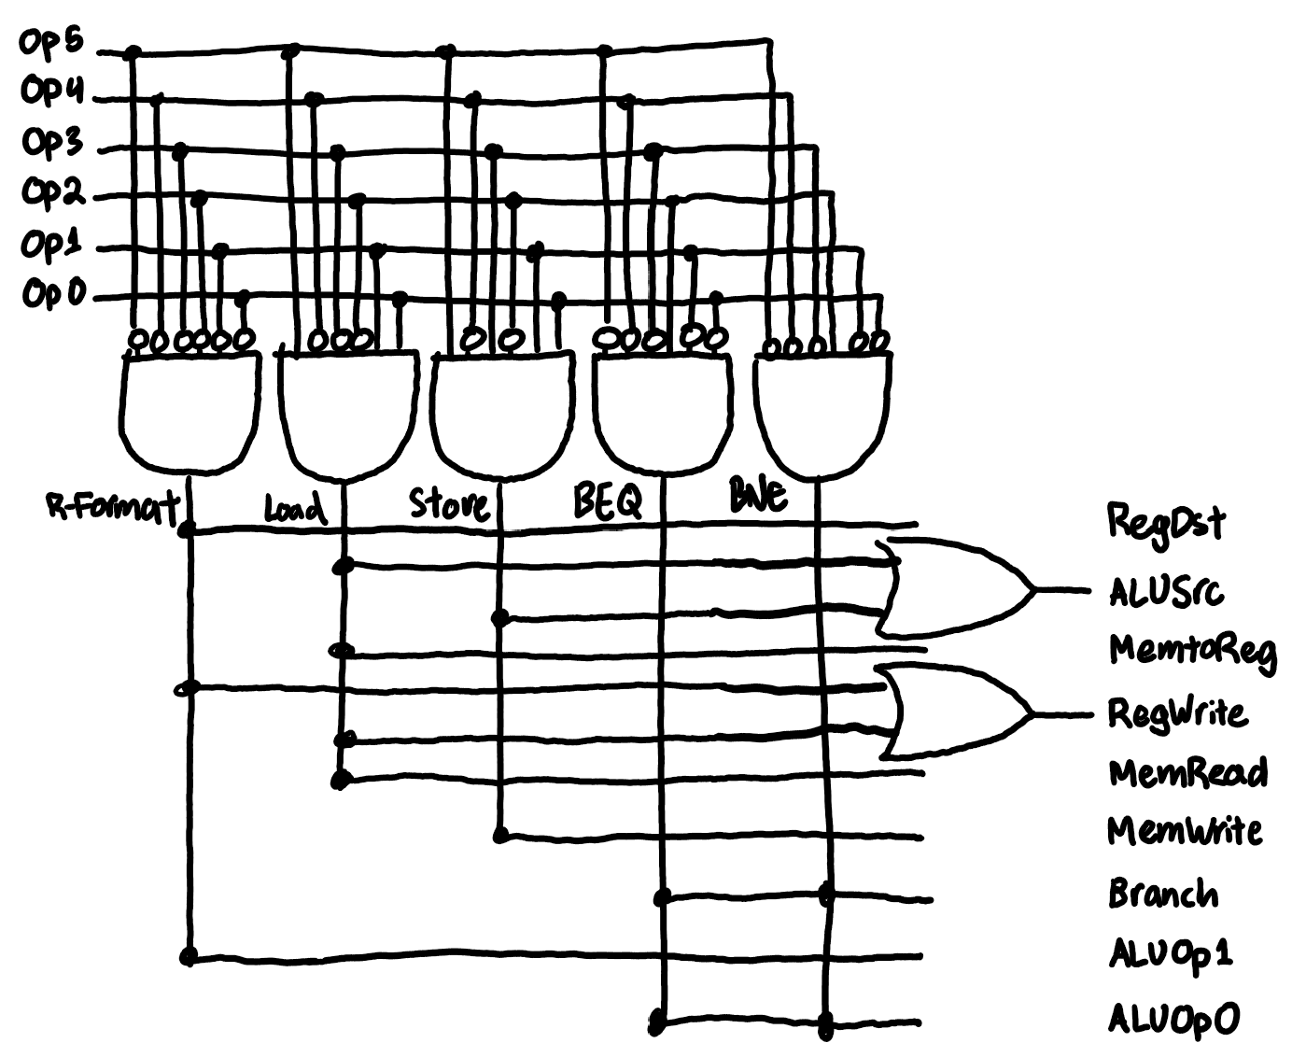
Figure 8. Gate level control logic

Verification

RAM
Simulation of the RAM was performed by reading preloaded values from memory and writing new values into the memory. The simulation was completed successfully with results as expected.
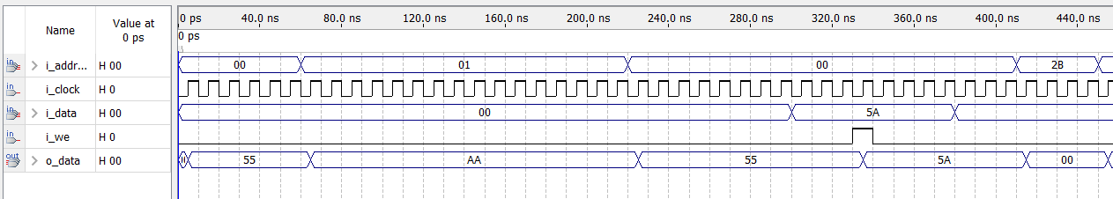
Figure 9. RAM Simulation

ROM
Simulation of the ROM was performed by reading preloaded values from instruction memory. The simulation was completed successfully with results as expected. The values shown as zero were programmed as zero.

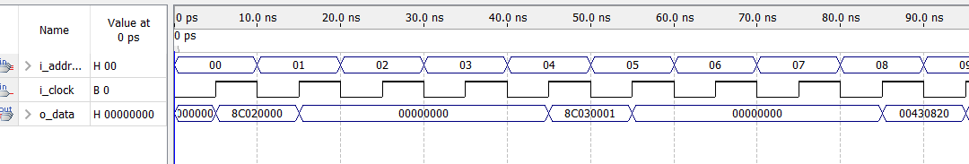
Figure 10. ROM Simulation

ALU
Simulation of the ALU was performed by asserting 2 values on the inputs and changing the operation input to test different operations. Separate inputs were used to check the ALU overflow flag as shown in the image. The simulation was completed successfully with results as expected.

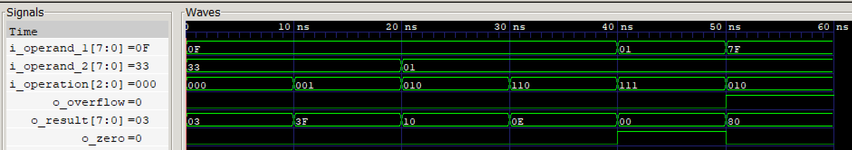
Figure 11. ALU Simulation

Control Path
Simulation of the control path was performed by testing the 4 different op codes from the 4 different instructions and ensuring the asserted control signals matched the table in the design. The simulation was completed successfully with results as expected.
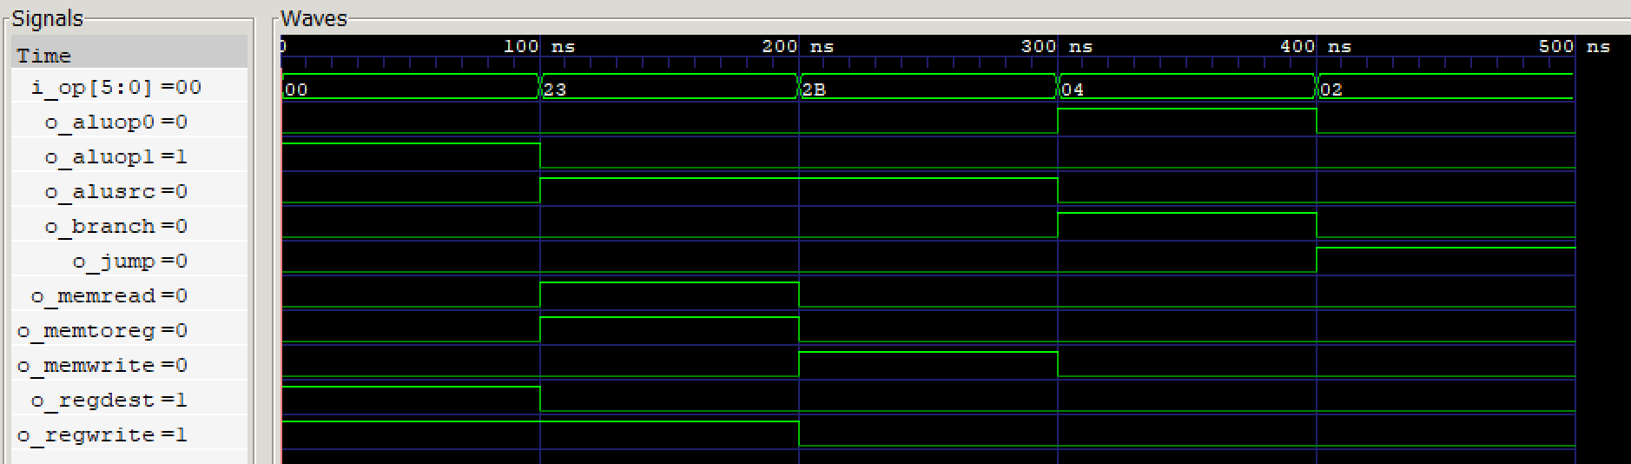
Figure 12. CPU Control Path Simulation

Sign Extension
Simulation of the sign extension unit was performed by testing a positive and negative number. When a positive number is received the sign extender should fill the “extended” bits with zeros and when a negative number is received the sign extender should fill the “extended” bits with ones. The simulation was completed successfully with results as expected.
Figure 13. Sign Extend Module

Demo

Top Level Entity
Simulation of the top-level entity was done by programming the MIF files with instructions and observing the behavior of the processor. As seen the figure below, the processor loads the first instruction while the reset signal is still asserted, and the program counter never advances to the next instruction. The issue was identified as a problem with the reset logic. Some components used an inverted reset signal (active low) while other components used a standard active high signal.
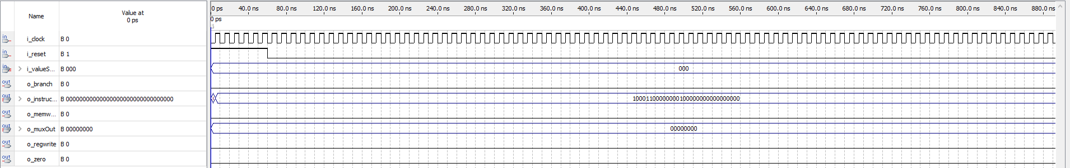
Figure 14. Top level entity simulation

Pin Assignments
Pine assignments were completed using a file provided with previous labs. 16 switches were used to enter the 16-bit operand values, 2 push buttons were used to set the values of A and B, and 2 more push buttons were used to reset the A and B registers and to reset the adder ASM.
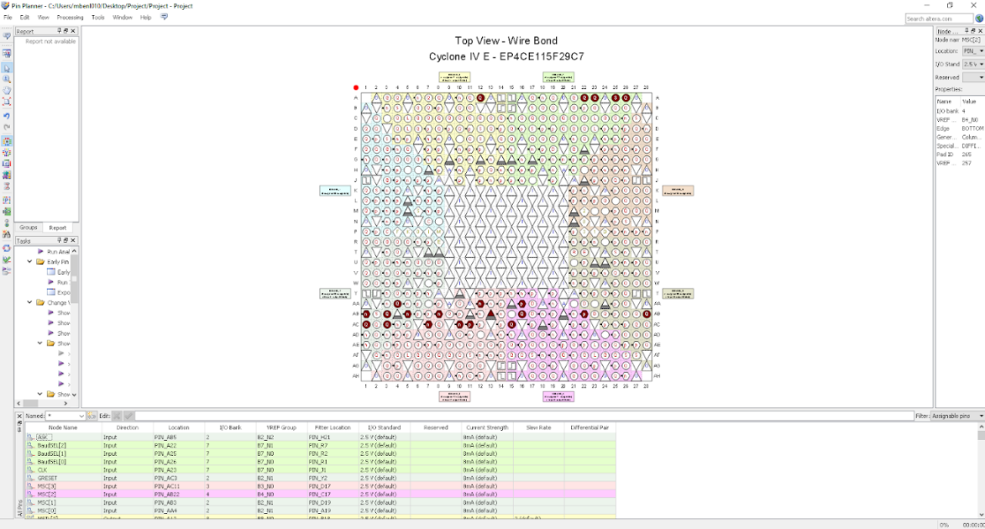
Figure 15: Pin Assignment

Bonus

32 Bit Design
In the 32-bit design bonus question, the challenge often revolves around managing the increased data width and ensuring efficient utilization of resources. To address this, it's crucial to optimize the data path and memory access to handle 32-bit wide data efficiently. This involves leveraging techniques like pipelining to enhance throughput and minimize latency. Additionally, ensuring that the ALU (Arithmetic Logic Unit) and other critical components are designed to support 32-bit operations without significant performance degradation is essential. Employing techniques such as parallel processing and ensuring that the control unit can handle the more complex instruction set efficiently will also contribute to a robust 32-bit design. Properly managing timing constraints and ensuring that the clock frequency is optimized for the wider data path are key to achieving a high-performance 32-bit system. Here is the updated Data Path with all considerations taken.
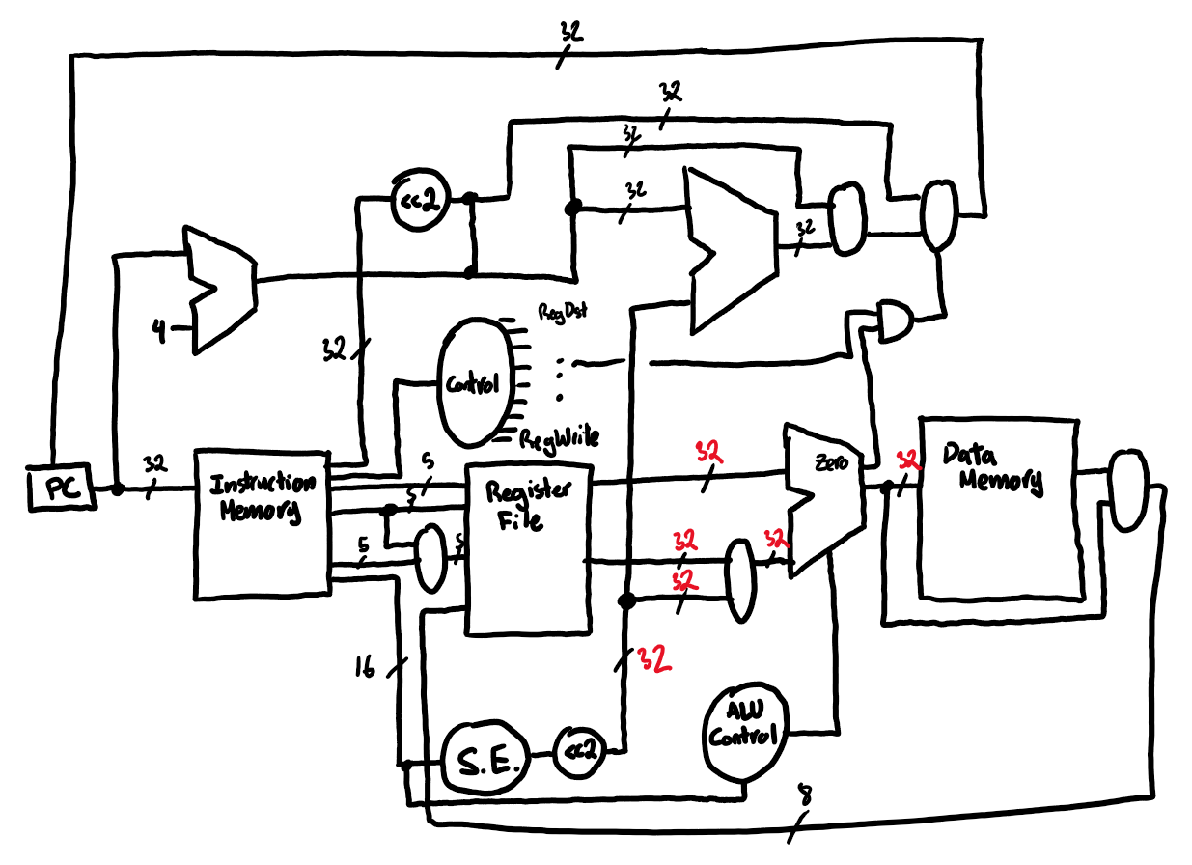
Figure 16. Modified Datapath

Multi-cycle Design
For the multi-cycle design bonus question, the primary focus is on optimizing the control unit to efficiently manage the different stages of instruction execution across multiple clock cycles. This involves breaking down instructions into distinct steps such as fetch, decode, execute, memory access, and write-back, with each step occurring in a separate cycle. The advantage of this approach is that it allows for the reuse of functional units, such as the ALU and memory, across different instructions, thereby reducing the overall hardware requirements. To enhance performance, it is crucial to minimize the number of cycles for each instruction by optimizing the control signals and state transitions. Additionally, implementing techniques like branch prediction and hazard detection can further improve the efficiency of a multi-cycle design. Ensuring that the memory hierarchy and data path are optimized for quick access and minimal latency will also contribute to a more efficient and high-performing multi-cycle processor.
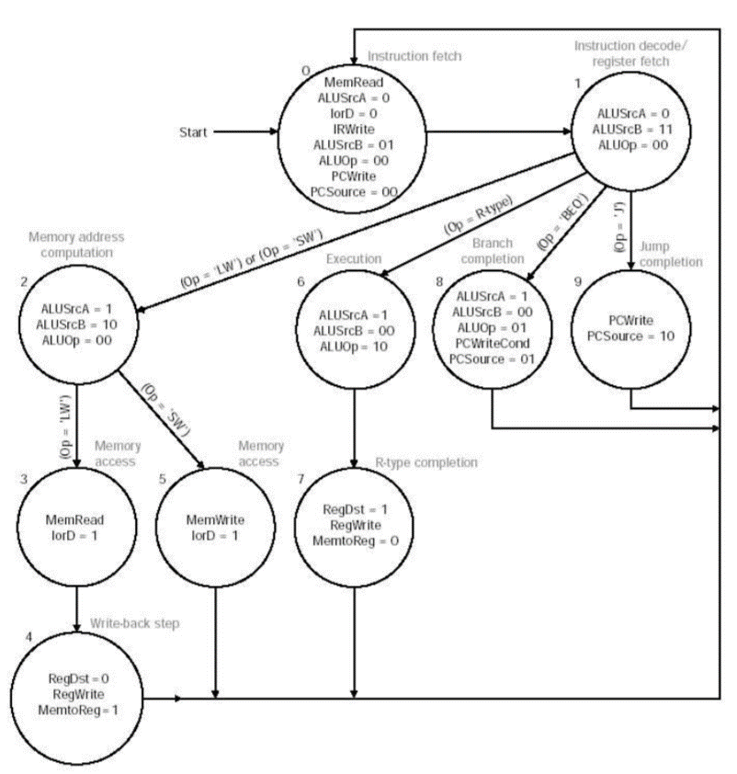
Figure 17. FSM Control Unit Studied in class

Comparison With Single Cycle
Assuming that the functional units used are the same (ALU, Register File, Memory Units, etc.), the multi-cycle clock period is significantly shorter than the single cycle one (will be 2ns ). The multi-cycle design breaks down the instruction execution into multiple stages, each occurring in separate clock cycles. This approach allows different instructions to take varying amounts of time to complete, based on their complexity. For instance, simpler instructions like ALU operations may only require a few cycles, while more complex instructions like load or store operations might take more cycles due to additional memory access stages. This results in a more efficient use of resources, as each functional unit (like the ALU or memory) is utilized in different cycles for different instructions, reducing the need for duplicating hardware.
In contrast, the single-cycle design mandates that all instructions complete within one clock cycle, necessitating a clock period long enough to accommodate the longest instruction path, often the memory access or branching instruction. This leads to an inefficient design where simpler instructions waste potential execution time, as they must wait for the clock period of the most complex instruction. The multi-cycle approach, therefore, optimizes performance by tailoring the clock period to the specific needs of each instruction class, leading to overall better resource utilization and potentially higher throughput.

Appendix

Hand calculations
Step | Instruction | State After Instruction
0 | lw $2, 0; | 2: 55
1 | lw $3, 1; | 2: 55  3: AA
2 | sub $1, $2, $3; | 1 : 55  2: 55  3: AA3
3 | or $4, $1, $3; | 1 : 55  2: 55  3: AA  4: FF
4 | sw $4, 3; | 1 : 55  2: 55  3: AA  4: FF  MEM:  3: FF
5 | add $1, $2, $3; | 1 : FF  2: 55  3: AA  4: FF  MEM:  3: FF
6 | sw $1, 4; | 1: FF  2: 55  3: AA  4: FF  MEM:  3: FF  4: FF
7 | lw $2, 3; | 1: FF  2: FF  3: AA  4: FF  MEM:  3: FF  4: FF
8 | lw $3, 4 | 1: FF  2: FF  3: FF  4: FF  MEM:  3: FF  4: FF
9 | j 11; | 1: FF  2: FF  3: FF  4: FF  MEM:  3: FF  4: FF
10 | beq $1, $2, -8; | 1: FF  2: FF  3: FF  4: FF  MEM:  3: FF  4: FF
11 | j 11; | 1: FF  2: FF  3: FF  4: FF  MEM:  3: FF  4: FF
12 | beq $1, $2, -8; | 1: FF  2: FF  3: FF  4: FF  MEM:  3: FF  4: FF
12 | Keeps looping forever

Test program in binary
- lw $2, 0($0)
  - Opcode: lw = 100011
  - Base: $0 = 00000
  - Destination: $2 = 00010
  - Offset: 0 = 0000 0000 0000 0000
  - Binary: 100011 00000 00010 0000 0000 0000 0000
- lw $3, 1($0)
  - Opcode: lw = 100011
  - Base: $0 = 00000
  - Destination: $3 = 00011
  - Offset: 1 = 0000 0000 0000 0001
  - Binary: 100011 00000 00011 0000 0000 0000 0001
- sub $1, $2, $3
  - Opcode: sub = 000000
  - Source 1: $2 = 00010
  - Source 2: $3 = 00011
  - Destination: $1 = 00001
  - Shift amount: 0 = 00000
  - Function: sub = 100010
  - Binary: 000000 00010 00011 00001 00000 100010
- or $4, $1, $3
  - Opcode: or = 000000
  - Source 1: $1 = 00001
  - Source 2: $3 = 00011
  - Destination: $4 = 00100
  - Shift amount: 0 = 00000
  - Function: or = 100101
  - Binary: 000000 00001 00011 00100 00000 100101
- sw $4, 3($0)
  - Opcode: sw = 101011
  - Base: $0 = 00000
  - Source: $4 = 00100
  - Offset: 3 = 0000 0000 0000 0011
  - Binary: 101011 00000 00100 0000 0000 0000 0011
- add $1, $2, $3
  - Opcode: add = 000000
  - Source 1: $2 = 00010
  - Source 2: $3 = 00011
  - Destination: $1 = 00001
  - Shift amount: 0 = 00000
  - Function: add = 100000
  - Binary: 000000 00010 00011 00001 00000 100000
- sw $1, 4($0)
  - Opcode: sw = 101011
  - Base: $0 = 00000
  - Source: $1 = 00001
  - Offset: 4 = 0000 0000 0000 0100
  - Binary: 101011 00000 00001 0000 0000 0000 0100
- lw $2, 3($0)
  - Opcode: lw = 100011
  - Base: $0 = 00000
  - Destination: $2 = 00010
  - Offset: 3 = 0000 0000 0000 0011
  - Binary: 100011 00000 00010 0000 0000 0000 0011
- lw $3, 4($0)
  - Opcode: lw = 100011
  - Base: $0 = 00000
  - Destination: $3 = 00011
  - Offset: 4 = 0000 0000 0000 0100
  - Binary: 100011 00000 00011 0000 0000 0000 0100
- j 11
  - Opcode: j = 000010
  - Address: 11 = 0000 0000 0000 0000 0000 0000 0000 1011
  - Binary: 000010 0000 0000 0000 0000 0000 1011
- beq $1, $1, -44
  - Opcode: beq = 000100
  - Source 1: $1 = 00001
  - Source 2: $1 = 00001
  - Offset: -44 = 1111 1111 1111 0100 (using two's complement)
  - Binary: 000100 00001 00001 1111 1111 1111 0100
- beq $1, $2, -8
  - Opcode: beq = 000100
  - Source 1: $1 = 00001
  - Source 2: $2 = 00010
  - Offset: -8 = 1111 1111 1111 1000 (using two's complement)
  - Binary: 000100 00001 00010 1111 1111 1111 1000
Final program:
- 10001100000000100000000000000000 0x8C020000
- 10001100000000110000000000000001 0x8C030001
- 00000000010000110000100000100010 0x014B4822
- 00000000001000110010000000100101 0x01236025
- 10101100000001000000000000000011 0xAC430003
- 00000000010000110000100000100000 0x014B4020
- 10101100000000010000000000000100 0xAC430004
- 10001100000000100000000000000011 0x8C430003
- 10001100000000110000000000000100 0x8C450004
- 00001000000000000000000000001011 0x0800002B
- 00010000001000011111111111110100 0x1001FFDC
- 00010000001000101111111111111000 0x1012FFF8

VHDL Components

Processor.vhd
LIBRARY ieee, lpm;
USE ieee.std_logic_1164.ALL;
USE lpm.lpm_components.ALL;

ENTITY Processor IS
PORT
(
i_valueSelect : IN STD_LOGIC_VECTOR(2 DOWNTO 0);
i_clock, i_reset : IN STD_LOGIC;
o_muxOut : OUT STD_LOGIC_VECTOR(7 DOWNTO 0);
o_instructionOut : OUT STD_LOGIC_VECTOR(31 DOWNTO 0);
o_branch, o_zero, o_memwrite, o_regwrite : OUT STD_LOGIC
);
END ENTITY Processor;

ARCHITECTURE rtl OF Processor IS
COMPONENT ROM
PORT
(
i_address: IN STD_LOGIC_VECTOR(7 DOWNTO 0);
i_clock : IN STD_LOGIC;
o_data: OUT STD_LOGIC_VECTOR(31 DOWNTO 0)
);
END COMPONENT;

COMPONENT RAM
PORT
(
i_data: IN STD_LOGIC_VECTOR(7 DOWNTO 0);
i_address: IN STD_LOGIC_VECTOR(7 DOWNTO 0);
i_clock : IN STD_LOGIC;
i_we: IN STD_LOGIC;
o_data: OUT STD_LOGIC_VECTOR(7 DOWNTO 0)
);
END COMPONENT;

COMPONENT ALU
PORT
(
i_OPERAND_1, i_OPERAND_2 : IN STD_LOGIC_VECTOR(7 DOWNTO 0);
i_OPERATION : IN STD_LOGIC_VECTOR(2 DOWNTO 0);
o_RESULT : OUT STD_LOGIC_VECTOR(7 DOWNTO 0);
o_ZERO : OUT STD_LOGIC;
o_OVERFLOW : OUT STD_LOGIC
);
END COMPONENT;

COMPONENT ALUControlUnit
PORT
(
i_FUNC_CODE : IN STD_LOGIC_VECTOR(5 DOWNTO 0);
i_ALU_OP : IN STD_LOGIC_VECTOR(1 DOWNTO 0);
o_OPERATION : OUT STD_LOGIC_VECTOR(2 DOWNTO 0)
);
END COMPONENT;

COMPONENT RegisterFile
PORT
(
i_readSelect1, i_readSelect2, i_writeSelect : IN STD_LOGIC_VECTOR(2 DOWNTO 0);
i_writeData : IN STD_LOGIC_VECTOR(7 DOWNTO 0);
i_clock, i_reset, i_regWrite : IN STD_LOGIC;
o_readData1, o_readData2 : OUT STD_LOGIC_VECTOR(7 DOWNTO 0)
);
END COMPONENT;

control : ControlUnit
PORT MAP
(
i_op => int_instructionMemoryOut(31 DOWNTO 26),
o_RegDest => int_RegDest,
o_ALUSrc => int_ALUSrc,
o_MemToReg => int_MemToReg,
o_RegWrite => int_regWrite,
o_MemRead => int_memWrite,
o_MemWrite => int_MemWrite,
o_Branch => int_Branch,
o_ALUOp0 => int_control_ALUOP(0),
o_ALUOp1 => int_control_ALUOP(1),
o_jump => open
);

registers : RegisterFile
PORT MAP
(
i_readSelect1 => int_instructionMemoryOut(23 DOWNTO 21),
i_readSelect2 => int_instructionMemoryOut(18 DOWNTO 16),
i_writeSelect => "000",
i_writeData => "00000000",
i_clock => i_clock,
i_reset => i_reset,
i_regWrite => int_regWrite,
o_readData1 => int_readData1,
o_readData2 => int_readData2
);

int_aluOperandA <= int_readData1;

int_offset <= int_instructionMemoryOut(15 DOWNTO 0);
signExtend : SignExtend16To32BitModule
PORT MAP
(
i_OPERAND => int_offset,
o_OUTPUT => int_offset_SE
);

END rtl;

ALU.vhd
LIBRARY IEEE;
USE IEEE.std_logic_1164.ALL;

ENTITY ALU IS
PORT
(
i_OPERAND_1, i_OPERAND_2 : IN STD_LOGIC_VECTOR(7 downto 0);
i_OPERATION : IN STD_LOGIC_VECTOR(2 downto 0);
o_RESULT : OUT STD_LOGIC_VECTOR(7 downto 0);
o_ZERO : OUT STD_LOGIC;
o_OVERFLOW : OUT STD_LOGIC
);
END ALU;

ARCHITECTURE RTL OF ALU IS

SIGNAL addersubtractor_result : STD_LOGIC_VECTOR(7 downto 0);
SIGNAL operand_bitwise_and : STD_LOGIC_VECTOR(7 downto 0);
SIGNAL operand_bitwise_or : STD_LOGIC_VECTOR(7 downto 0);
SIGNAL int_zero : STD_LOGIC;

COMPONENT EightBitAdderSubtractor is
PORT
(
InputA, InputB : IN STD_LOGIC_VECTOR(7 downto 0);
Operation : IN STD_LOGIC;
Result : OUT STD_LOGIC_VECTOR(7 downto 0);
CarryOUT : OUT STD_LOGIC
);
END COMPONENT;

COMPONENT EightBitComparator IS
PORT
(
i_Ai, i_Bi : IN STD_LOGIC_VECTOR(7 DOWNTO 0);
o_GT, o_LT, o_EQ : OUT STD_LOGIC
);
END COMPONENT;

COMPONENT EightToOne8BitMux IS
PORT (
i_mux_0, i_mux_1, i_mux_2, i_mux_3 : IN STD_LOGIC_VECTOR(7 downto 0);
i_mux_4, i_mux_5, i_mux_6, i_mux_7 : IN STD_LOGIC_VECTOR(7 downto 0);
o_mux: OUT STD_LOGIC_VECTOR(7 downto 0);
sel0, sel1, sel2: IN STD_LOGIC
);
END COMPONENT;

BEGIN

operand_bitwise_and <= i_OPERAND_1 and i_OPERAND_2;
operand_bitwise_or <= i_OPERAND_1 or i_OPERAND_2;

addersubtractor : EightBitAdderSubtractor
PORT MAP
(
InputA => i_OPERAND_1,
InputB => i_OPERAND_2,
Operation => i_OPERATION(2),
Result => addersubtractor_result,
CarryOUT => o_OVERFLOW
);

zero_comparator: EightBitComparator
PORT MAP
(
i_Ai => addersubtractor_result,
i_Bi => "00000000",
o_GT => open,
o_LT => open,
o_EQ => int_zero
);

mux : EightToOne8BitMux
PORT MAP
(
i_mux_0 => operand_bitwise_and,
i_mux_1 => operand_bitwise_or,
i_mux_2 => addersubtractor_result,
i_mux_3 => "00000000",
i_mux_4 => "00000000",
i_mux_5 => "00000000",
i_mux_6 => addersubtractor_result,
i_mux_7 => "00000000",
o_mux => o_RESULT,
sel0 => i_OPERATION(0),
sel1 => i_OPERATION(1),
sel2 => i_OPERATION(2)
);

o_ZERO <= i_OPERATION(0) and i_OPERATION(1) and i_OPERATION(2) and int_zero;

END RTL;

All code:
All code from the Quartus project can be found here: https://github.com/chriswkingg/ceg3156-lab/tree/main/Lab%201

